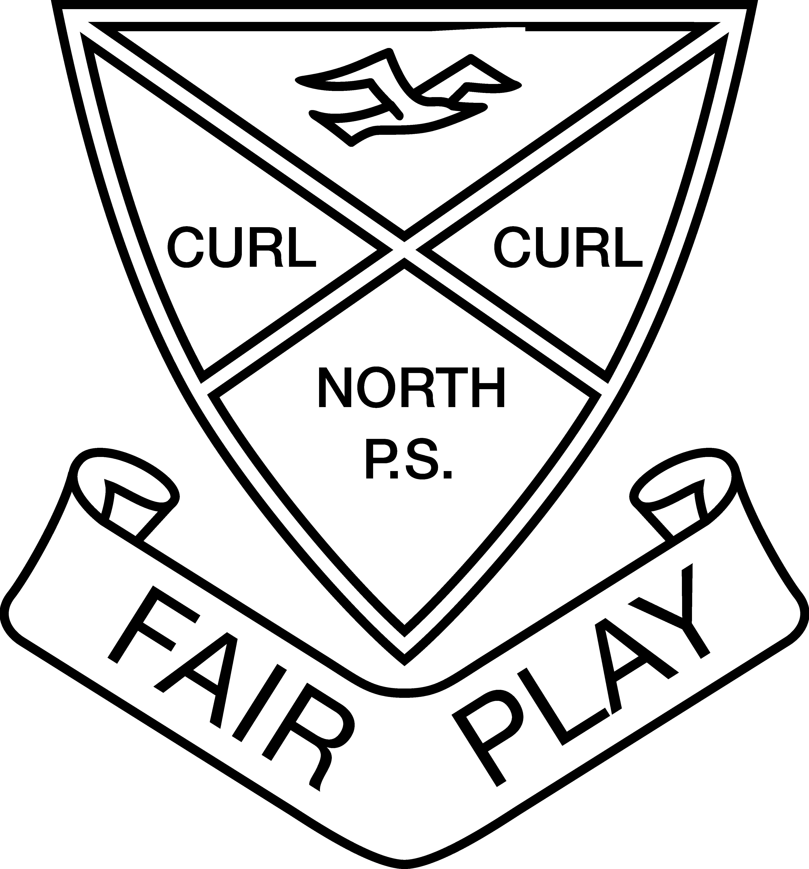

11 August 2016

Dear Parents and Carers

This term, your school is taking part in the Tell Them From Me student survey. The survey will provide us with valuable feedback on what our students think about school life, how engaged they are with school and the different ways that teachers interact with them. Schools in Australia and around the world have used the Tell Them From Me survey to help them improve. The survey is completed on-line and is run by an independent research company, The Learning Bar, which specialises in school-based surveys.

Staff in schools will not be able to identify individual students from their responses. To ensure confidentiality, participating students will receive a unique username and password. Where fewer than five students respond to a question, the results will be suppressed. The survey typically takes 30 minutes or less to complete and will be administered by the school during normal school hours. Once the surveys are completed by students, reports are prepared and in most cases are available to schools within three business days.

This survey will help your school better understand how to improve student wellbeing and engagement. It will help the school identify what works to improve student outcomes.

Participating in the survey is entirely voluntary. Your child will not take part if either you or your child do not wish. If, during the survey, your child is uncomfortable, he/she can choose to stop the survey at any time. The majority of questions in the survey can be skipped.

If you do not want your child to take part in the survey, please complete the attached form and return it to your child's school by Monday 22 August 2016.

More information about the survey and the research is available in English on the CESE website: http://surveys.cese.nsw.gov.au/information-for-parents

Mrs Judith Smith Dr Jenny Donovan

Principal Executive Director

Curl Curl North Public School Centre for Education Statistics and Evaluation

Tell Them From Me Student Feedback Survey non-consent form

If you do not want your child to participate in the student feedback survey, please sign this form and return it to your school by Monday 22 August 2016.

I DO NOT give consent for my child/children to participate in the Tell Them From Me student feedback survey.

Name of student/s ……………………………………………………………………………..

Roll class/es …………………………………………………………………………………….

Name of parent/carer ………………………………………………………………………...

Signature of parent/carer …………………………………………………………………….

Date …………………...................

Tell Them From Me Student Feedback Survey non-consent form

If you do not want your child to participate in the student feedback survey, please sign this form and return it to your school by Monday 22 August 2016.

I DO NOT give consent for my child/children to participate in the Tell Them From Me student feedback survey.

Name of student/s ……………………………………………………………………………..

Roll class/es …………………………………………………………………………………….

Name of parent/carer ………………………………………………………………………...

Signature of parent/carer …………………………………………………………………….

Date …………………...................

